Agility 2018 Hands-on Lab Guide

APM 130 Introduction to Universal Access with F5

Presented by:

Daniel Cayer, Satvayan Kosok, Mathew Faber, Michael Slavinsky

What’s inside

Welcome 1

Lab Environment Setup 1

Timing for Labs 2

Accessing the Lab Environment 3

LAB 1: System Setup 3

Objectives 3

Lab Requirements 4

Task 1: Create a pool 4

Task 2: Create HTTP Virtual Server with redirect 5

Task 3: Create HTTPS Virtual Server 6

Task 4: Testing 8

Lab 2: Create My First Policy 8

Objectives 8

Lab Requirements 9

Task 1: Define an Authentication Server 9

Task 2: Create a Simple Access Profile 10

Task 3: Associate Access Policy to Virtual Servers 17

Task 4: Testing 17

Lab 3: Configuring a VPN Policy 19

Objectives 19

Lab Requirements 19

Task 1: Use the Wizard to create a new Remote Access service 19

Task 2: Testing 22

Lab 4: Configuring an APM Webtop 23

Objectives 23

Lab Requirements 23

Task 1: Create a Webtop resource 24

Task 2: Enable “Content Rewrite” on the Virtual Server 24

Task 3: Add Webtop resource to existing Access Policy 25

Task 4: Testing 27

Lab 5: FORMS Based Authentication 28

Objectives 28

Lab Requirements 28

Task 1: Create a Pool 28

Task 2: Create a Virtual Server 29

Task 3: Testing without APM 31

Task 4: Create Access Policy to use with Forms Based Authentication 32

Task 5: Applying Access Policy Changes 37

Task 6: Testing with APM Authentication 38

Task 7: Testing Logout 39

Lab 6: BASIC Authentication 40

Objectives 40

Lab Requirements 40

Task 1: Create a Pool 40

Task 2: Create a Virtual Server 41

Task 3: Testing without APM 43

Task 4: Create Access Policy to use with Forms Based Authentication 44

Task 5: Applying Access Policy 48

Task 6: Testing with APM Authentication 49

Task 7: Testing Logout 50

Lab 7: Single-Sign-On Across Authentication Domains 51

Objectives 51

Lab Requirements 51

Task 1: Verify Authentication Required for different applications 51

Task 2: Specify Domain Cookie 52

Task 3: Testing Authentication across domains 53

Task 4 (Bonus): Authentication across domains & virtual servers 53

# Welcome

This is the lab guide for “**APM 130: Introduction to Universal Access with F5**”. Students will learn concepts of APM and will be guided through configuration steps for common use cases, including setting up remote access VPN services, web portals (Webtops) for publishing internal applications, using different authentication protocols and Single-Sign-On (SSO) functionality.

## Lab Environment Setup

In the interest of time, the following components have been setup with basic configurations for you ahead of time:

* Cloud-based lab environment complete with a Jump Host, a Virtual BIG-IP (VE) and a Server running AD and Web services
* Local Host file entries on the Jump Host:
* 10.128.10.10 www.f5demo.com
* 10.128.10.11 myvpn.f5demo.com
* 10.128.20.200 www2.f5demo.com
* 10.128.10.11 webtop.f5demo.com
* 10.128.10.12 forms.f5demo.com
* 10.128.10.13 basic.f5demo.com
* 10.128.10.13 app1.f5demo.com
* 10.128.10.13 app2.f5demo.com
* 10.128.10.13 app3.f5demo.com
* 10.128.1.245 bigip1.f5demo.com
* Unique and independent instances of the Lab environment for each student
* Virtual Edition BIG-IP has been pre-licensed and provisioned for Local Traffic Manager (LTM) and Access Policy Manager (APM)

The following diagram illustrates the lab environment’s network configuration and will be useful if you wish to replicate these exercises in your own lab environment:

Lab Environment Diagram



## Timing for Labs

The time it takes to perform each lab varies and is mostly dependent on accurately completing steps. Below is an estimate of how long it will take for each lab:

Lab Timing

|  |  |
| --- | --- |
| Lab name (Description) | Time Allocated |
| Lab 1: System Setup | 10 minutes |
| Lab 2: Create My First Policy | 15 minutes |
| Lab 3: Configuring a VPN Policy | 20 minutes |
| Lab 4: Configuring an APM Webtop | 10 minutes |
| Lab 5: Forms Based Authentication | 15 minutes |
| Lab 6: Basic Authentication | 15 minutes |
| Lab 7: Single-Sign-On Across Authentication Domains | 20 minutes |

## Accessing the Lab Environment

To access the lab environment, you will require a web browser and Remote Desktop Protocol (RDP) client software. The web browser will be used to access the Lab Training Portal. The RDP client will be used to connect to the Jump Host, where you will be able to access the BIG-IP management interfaces (HTTPS, SSH).

You class instructor will provide additional lab access details, including credentials.

1. Establish an RDP connection to your Jump Host and login with the following credentials:

* User: **user**
* Password: **Agility1**

1. Access the **BIG-IP** GUI **https://10.128.1.245** (you can double-click on the red “f5 Big-IP” shortcut icon on the Windows desktop).
2. Login into the BIG-IP Configuration Utility with the following credentials:

* User: **admin**
* Password: **admin**

# LAB 1: System Setup

## Objectives

In this lab, we will configure resources including Virtual Servers, Pools, and monitors that we will use as the foundation for subsequent labs.

## Lab Requirements

* BIG-IP with APM licensed and activated
* Web site up and running at 10.128.20.200:80, 10.128.20.201:80 and 10.128.20.202:80

## Task 1: Create a pool

1. Browse to **Local Traffic >** **Pools** and click the ‘**+**’ next to **Pools List** to create a new pool.
2. Name the pool in “**http_pool**”
3. Assign the monitor “**http**” by selecting it and sliding it to the left.
4. **Add** the following “new node” members to the pool:
   * Address: **10.128.20.200** Service Port **80**
   * Address: **10.128.20.201** Service Port **80**
   * Address: **10.128.20.202** Service Port **80**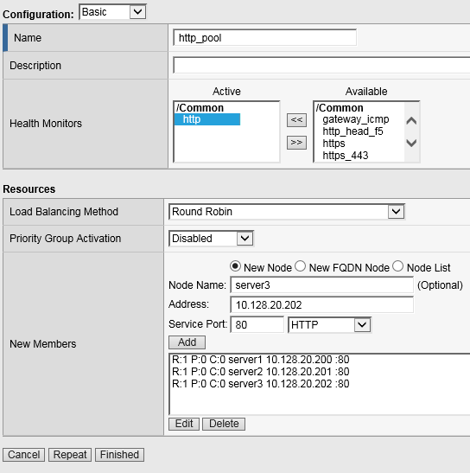
5. Click **Finished**

## Task 2: Create HTTP Virtual Server to redirect to HTTPS

1. Create a new Virtual Server by browsing to **Local Traffic** > **Virtual Servers** > **Virtual Server List** and click the ‘**+**’ to create a new one.
2. Name the Virtual Server in the following format **http_vs_redir**. For “Destination Address/Mask”, use **10.128.10.10"**. For “Service Port”, use **80**.
3. For “HTTP Profile” choose the default http profile called **http**
4. Under iRules at the bottom of the screen, select the **sys_https_redirect** irule from the “Available” list and slide it over to the “Enabled” list and click **Finished**.

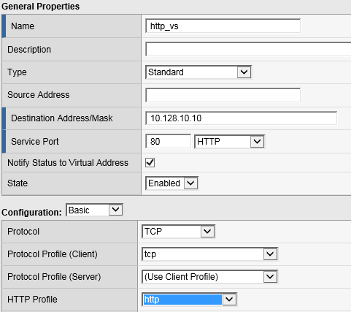

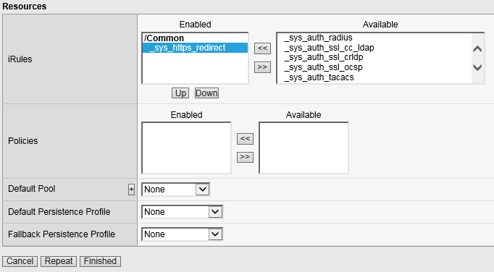

## Task 3: Create HTTPS Virtual Server

1. Create a new Virtual Server by browsing to **Local Traffic** > **Virtual Servers** > **Virtual Server List** and click the ‘**+**’ to create a new one.
2. Name the Virtual Server in the following format **https_vs** .
3. For “Destination Address/Mask”, use **10.128.10.10**. For “Service Port”, use **443**.
4. For “HTTP Profile”, choose the default **http** profile
5. For “SSL Profile (Client)”, choose the **f5demo**, slide it over to the “Selected” column
6. For “Source Address Translation”, choose **Auto Map**
7. For “Default Pool”, select the pool created earlier. It should be named **http_pool**

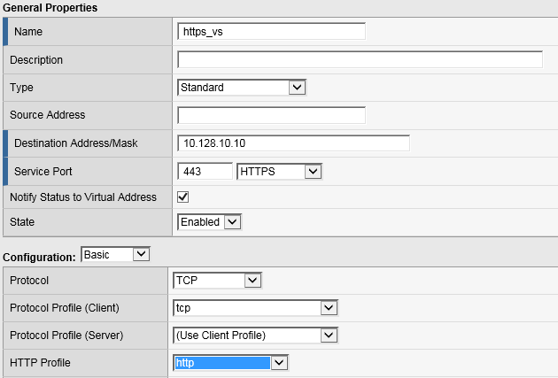

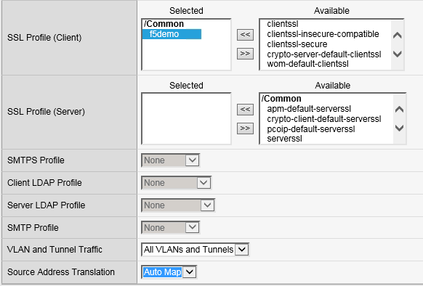

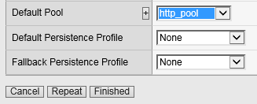

1. Click **Finished**

## Task 4: Testing

You should now be able to browse to either Virtual Server (HTTP or HTTPs) and you should get the same page. Try: [**http://www.f5demo.com**](http://www.f5demo.com) **and** [**https://www.f5demo.com**](https://www.f5demo.com)

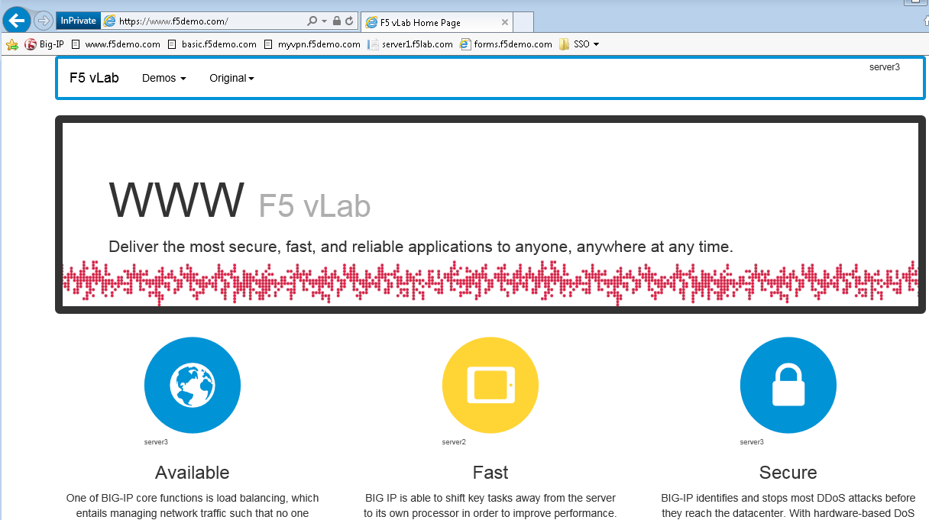

# Lab 2: Create My First Policy

## Objectives

In this lab, we will use the resources configured in the previous lab and configure a simple Access Profile using the Visual Policy Editor (VPE) to perform user authentication.

## Lab Requirements

* Working HTTP and HTTPS Virtual Servers (from Lab 1)

## Task 1: Define an Authentication Server

Before we can create an access profile, we must create the necessary AAA server profile for our Active Directory.

1. From the main screen, browse to **Access > Authentication > Active Directory**
2. Click **Create…** in the upper right-hand corner
3. Configure the new server profile as follows:

Name: **Lab_SSO_AD_Server**

Domain Name: **f5demo.com**

Server Connection: **Direct**

Domain Controller: **10.128.20.200**

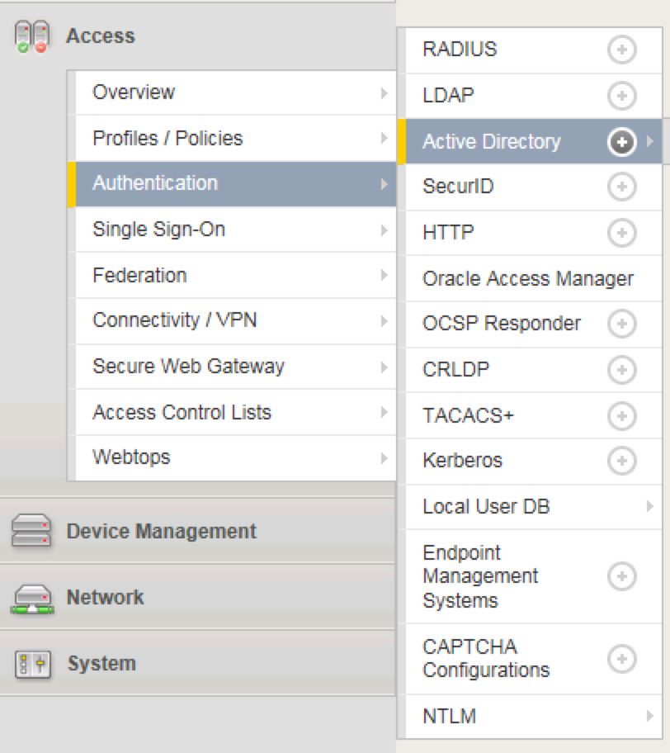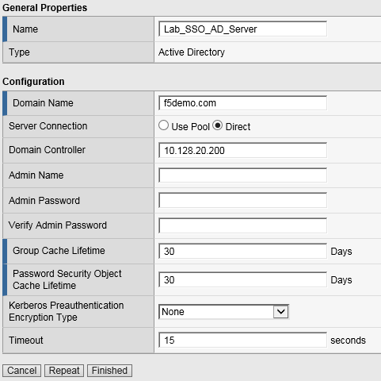

1. Click **Finished**

## Task 2: Create a Simple Access Profile

1. Navigate to **Access > Profiles / Policies > Access Profiles (Per-Session Policies)**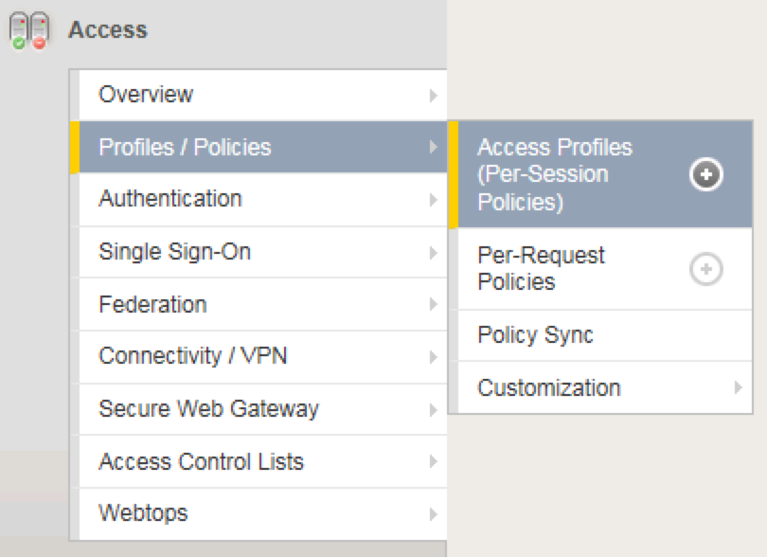
2. From the Access Profiles screen, click **Create...** in the upper right-hand corner
3. In the Name field, enter “**MyAccessPolicy**”, and for “Profile Type”, select the dropdown and choose **All**  
   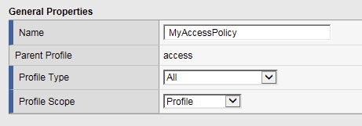
4. Under “Language Settings”, choose **English** and click the “**<<**“ button to slide over to the “Accepted Languages” column**.**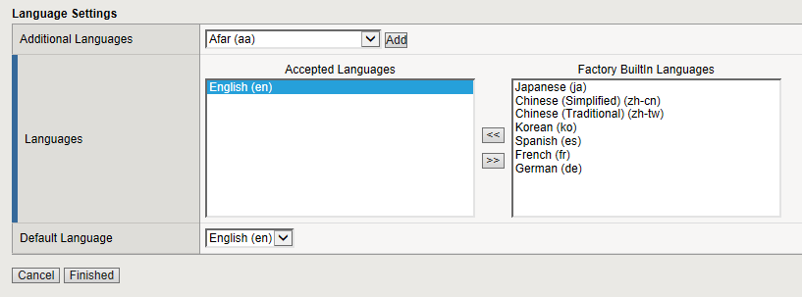
5. Click **Finished**, which will bring you back to the Access Profiles screen.
6. On the Access Profiles screen, click the **Edit** link under the Per-Session Policy column. 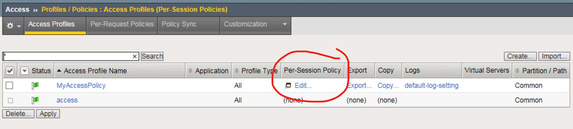  
   The Visual Policy Editor (VPE) will open in a new tab.
7. On the VPE page, click the ‘**+**’ icon on the “fallback” path, to the right of the **Start** object.  
     
     
   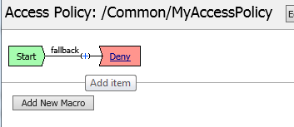
8. On the popup menu, choose the **Logon Page** radio button under the Logon tab and click **Add Item.**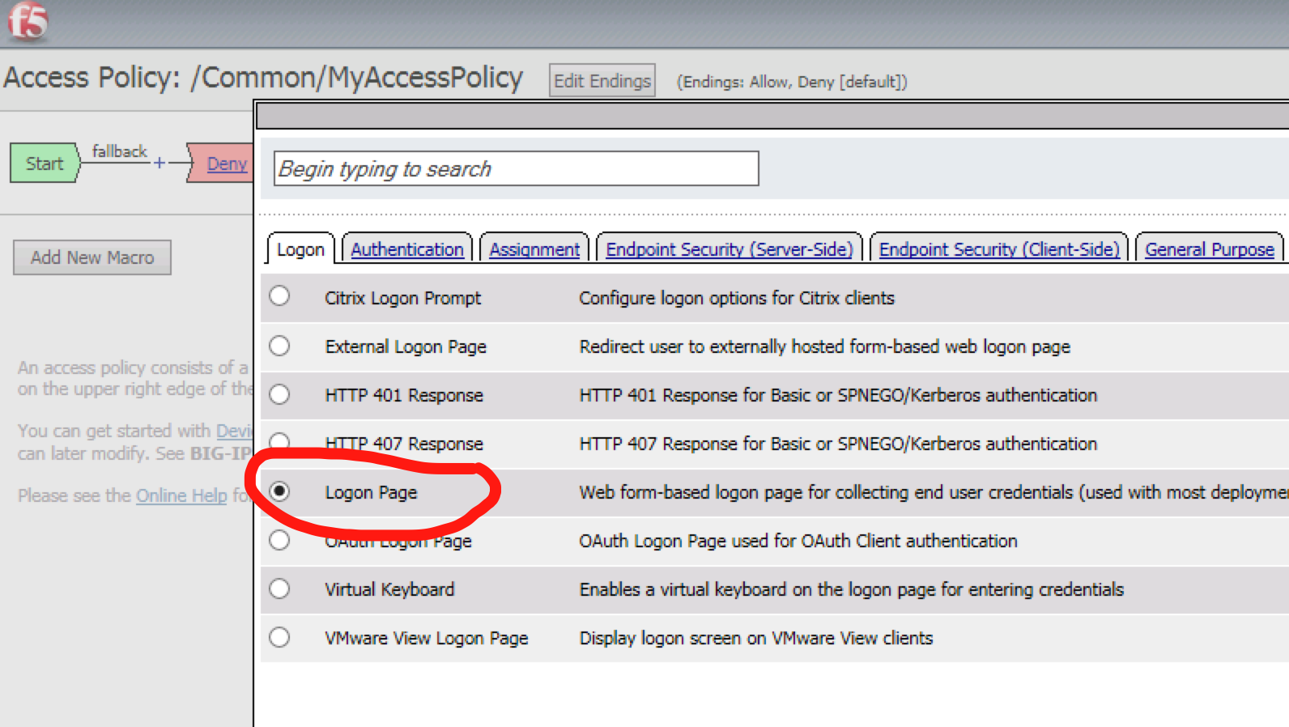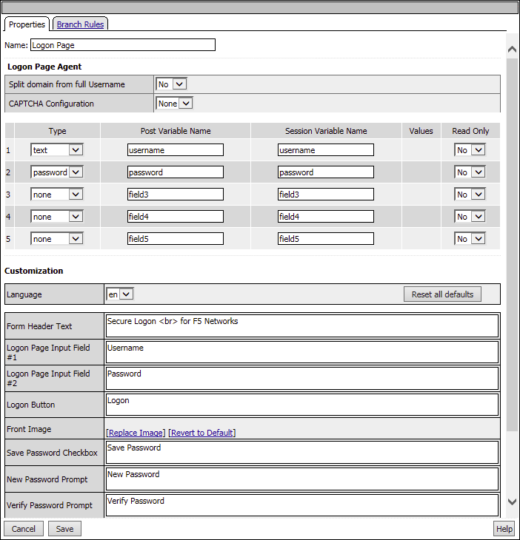
9. Accept the defaults and click **Save**

Now let’s authenticate the client using the credentials to be provided via the “Logon Page” object.

1. Between the “Logon Page” and “Deny” objects, click the ‘**+**’ icon, select **AD Auth** found under the **Authentication** tab, and click the **Add Item** button  
   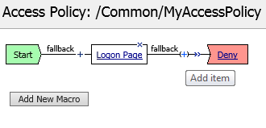  
     
   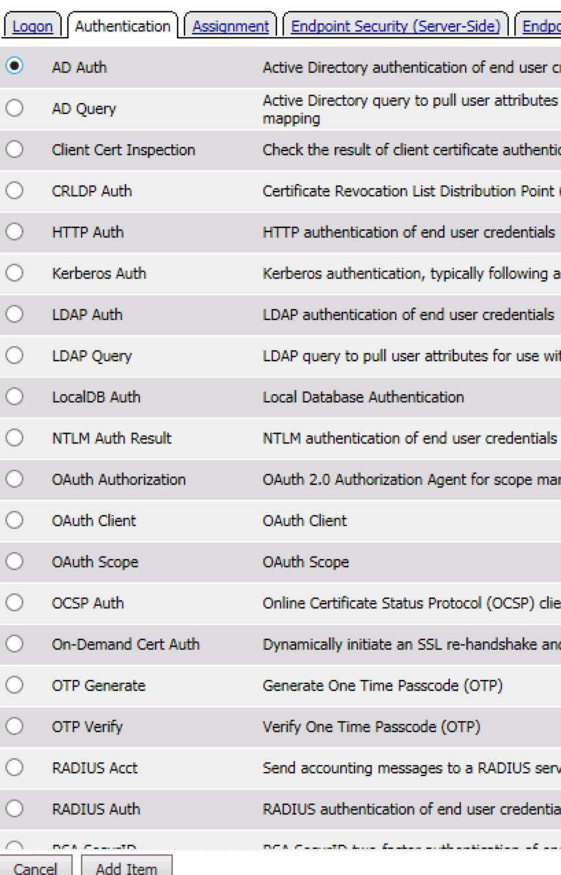
2. Accept the default for the **Name** and in the **Server** drop-down menu select the AD server created above: **/Common/LAB_SSO_AD_Server**, then click **Save**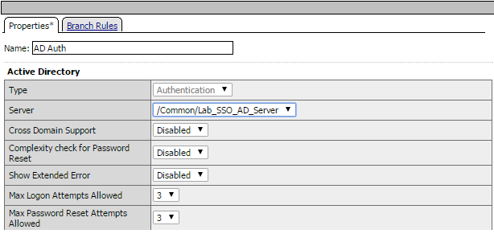
3. On the “Successful” branch between the **AD Auth** and **Deny** objects, click on the word **Deny** to change the ending  
   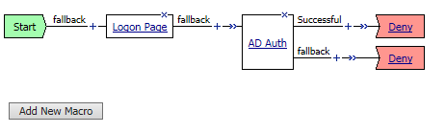
4. Change the “Successful” branch ending to **Allow**, then click **Save**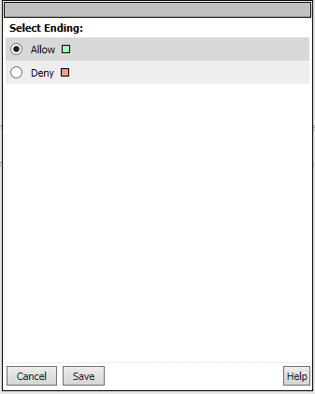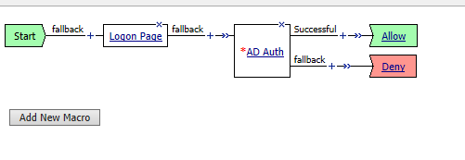
5. In the upper left-hand corner of the screen, click on the **Apply Access Policy** link, then close the window using the **Close** button in the upper right-hand. Click **Yes** when asked “Do you want to close this tab?”  
   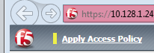 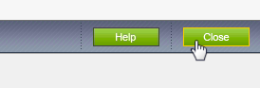

## Task 3: Associate Access Policy to Virtual Servers

Now that we have created an access policy, we must apply it to the appropriate virtual server to be able to use it.

1. From the **Local Traffic** menu, navigate to the **Virtual Servers List** and click the name of the virtual server created previously: **https_vs**.
2. Scroll down to the “Access Policy” section, then for the “Access Profile” dropdown, select **MyAccessPolicy**  
   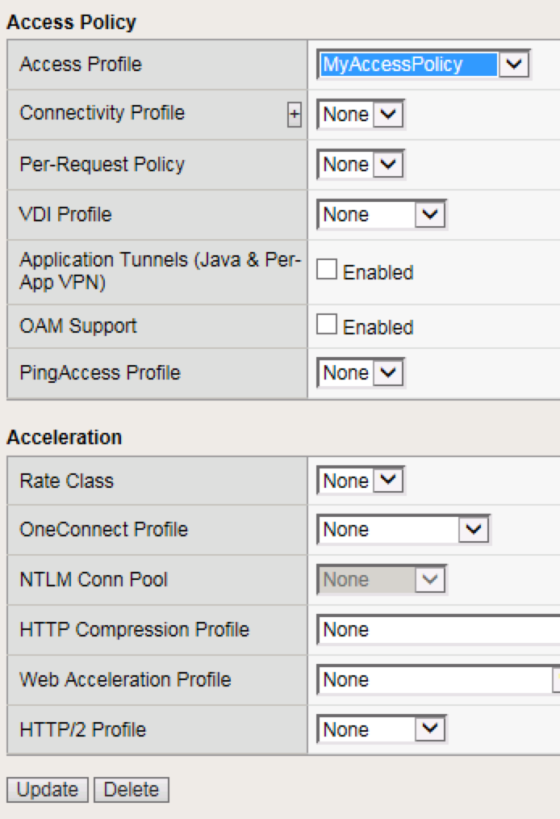
3. Click **Update** at the bottom of the screen

## Task 4: Testing

Now you are ready to test.

1. Open a new browser window and open the URL for the virtual server that has the access policy applied: [**https://www.f5demo.com**](https://www.f5demo.com)You will be presented with a login window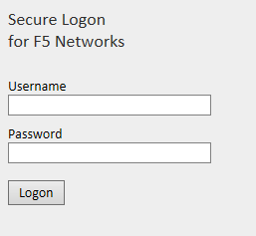
2. Enter the following credentials and click **Logon**:

Username: **user**

Password: **Agility1**

You will see a screen similar to the following:  


# Lab 3: Configuring a VPN Policy

## Objectives

In this lab, we will use the Device Wizard to configure a new SSL VPN service with the necessary Network Access Resources on APM.

## Lab Requirements

* BIG-IP with APM licensed and activated
* Server running AD and Web services
* Local Host file entries on the Jump Host

## Task 1: Use the Wizard to create a new Remote Access service

1. From the main menu on the left side of the screen, browse to the **Wizards > Device Wizards** and select the radio button for “**Network Access Setup Wizard for Remote Access**”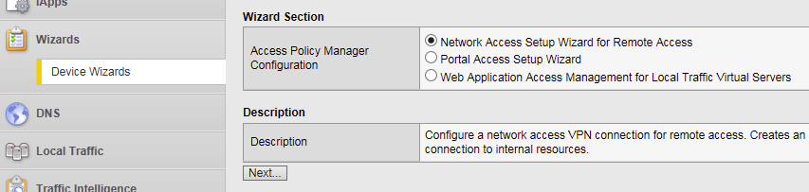
2. Click **Next**
3. For the Policy Name field, enter **MyVPNPolicy**. This should auto populate the caption field. **Uncheck** the“**Enable Antivirus Check in Access Policy**”checkbox and click **Next**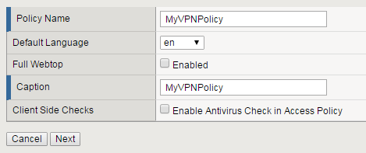
4. From the Select Authentication screen, choose the “**Use Existing**” radio button, select the AAA server "**Lab_SSO_AD_Server::Active Directory**” configured previously in Lab 2 and click **Next**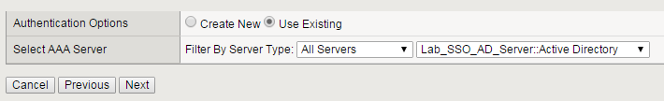
5. Assign an IP Address Range to be used for the VPN connection on the “Configure Lease Pool” page. Click the radio button for “**IP Address range**” and enter the range “**10.1.1.1-10.1.1.2**”,click **Add** and click **Next**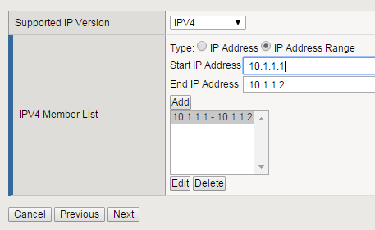
6. On the “Configure Network Access” page, select "**Use split tunneling for traffic**” and for “IPV4 Lan Space”, enter the network “**10.128.20.0”**, mask“**255.255.255.0”,** click **Add**, leave everything else default and click **Next**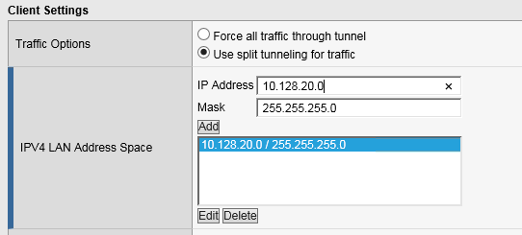
7. Accept the default on the “Configure DNS Hosts for Network Access” page and click **Next**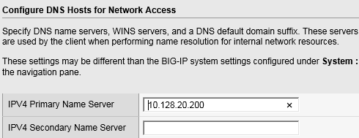
8. On the “Virtual Server (HTTPS connection)” page, enter “**10.128.10.11**” for the IP address of the Virtual Server that users will connect to for access to the VPN. **Uncheck** the “**Create Redirect Virtual Server**” option and click **Next**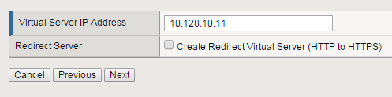
9. Verify your settings on the Review page and click **Next** when satisfied.
10. The Setup Summary page will display a list of the configuration objects that the Wizard created for you. Click **Finished**

## Task 2: Testing

1. Open a web browser to the virtual server created in the above step by navigating to **https://myvpn.f5demo.com**. You will be presented with a Logon page similar to the one from the last lab.  
   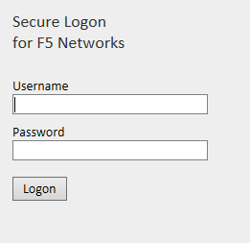
2. Enter the following credentials:

Username: **user**

Password: **Agility1**

This will initialize, authenticate and establish a new VPN connection to the Network Resource that was configured. You will be presented with a new page that shows the connection details.  
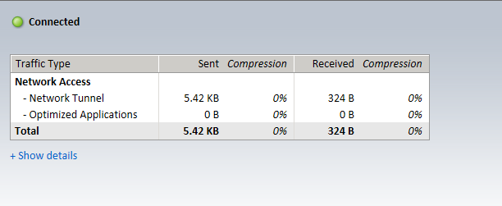

1. Open a new browser tab and confirm that you are now connected to the internal network by browsing directly to the HTTP server used in the pool for the previous labs: [**http://server1.f5demo.com**](http://server1.f5demo.com). You should see a page similar to the following:  
   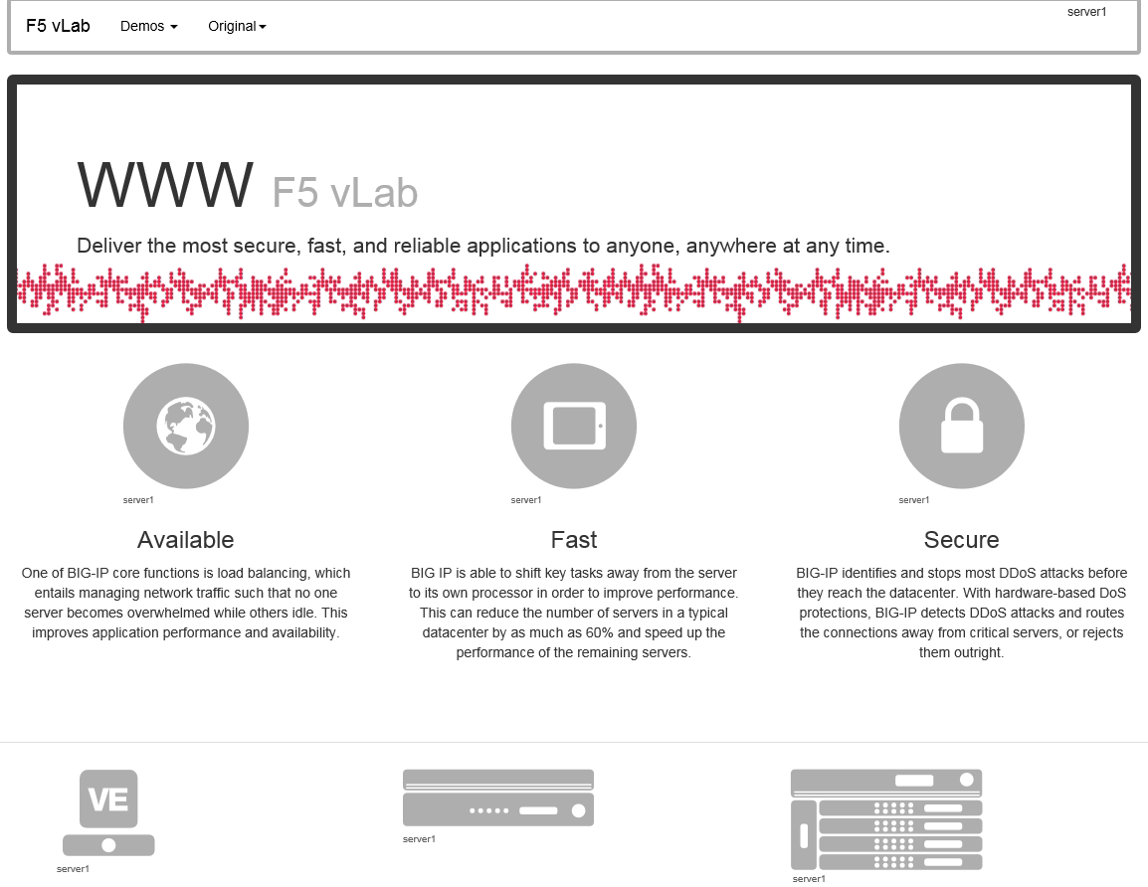
2. Close the page then click **Logout** on the F5 VPN page to terminate your VPN connection and close the browser window.

# Lab 4: Configuring an APM Webtop

## Objectives

In this lab, we will add a Webtop resource to the Access Policy previously created in lab 2.

## Lab Requirements

* Working HTTPS Virtual Server created in Lab 1 with Access Policy created in Lab 2 (Lab 2 successfully completed)

## Task 1: Create a Webtop resource

1. Expand the **Access** tab from the main menu on the left and navigate to **Webtops** > **Webtop** **Lists**
2. Click **Create** to create a new Webtop called **MyFullWebtop**, select Type “**Full**”, uncheck “**Minmize To Tray**” and click **Finished**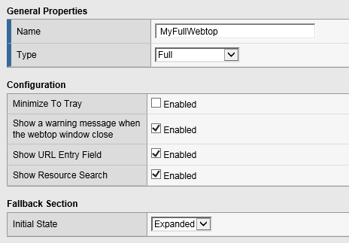

## Task 2: Enable “Content Rewrite” on the Virtual Server

1. Browse to **Local Traffic** > **Virtual Servers >** **Virtual Server List** and click on the name of your VPN Virtual Server called **MyVPNPolicy_vs**.
2. Scroll down to the “Content Rewrite” section, select “**rewrite**” for the “Rewrite Profile” field and click **Update**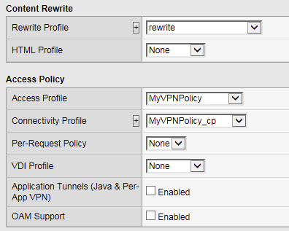

## Task 3: Add Webtop resource to existing Access Policy

1. Browse to **Access** > **Profiles / Policies > Access Profiles (Per-Session Policies)**, click on **Edit** for **MyVPNPolicy**. A new tab should open to the Visual Policy Editor for **MyVPNPolicy**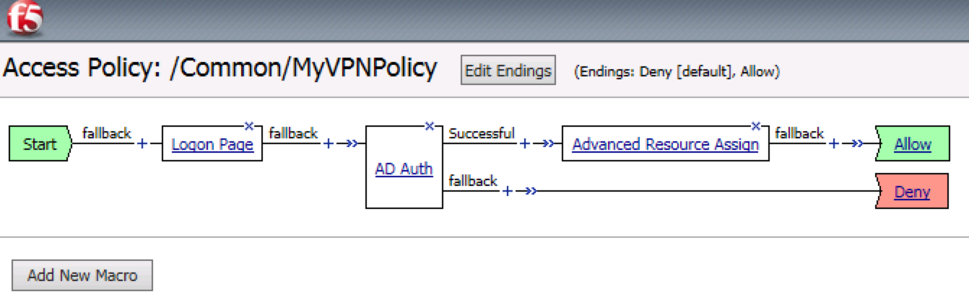
2. Select the **Advanced Resource Assign** object
3. Click **Add/Delete**
4. Click on the **Webtop** tab, select the radio button for **MyFullWebtop**, then click the **Update** button at the bottom of the screen  
   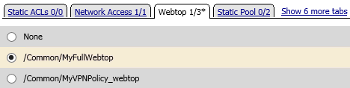
5. Click **Save**
6. At the top left of the browser window, click on “**Apply Access Policy**”, then close the tab  
   

## Task 4: Testing

1. Open a web browser to the virtual server created in the previous lab by navigating to **https://myvpn.f5demo.com**. You will be presented with a Logon page similar to the one from the last lab.
2. Enter the following credentials:

Username: **user**

Password: **Agility1**

1. Click **Logon**

This will open the APM Webtop landing page that shows the resources you are allowed to access. In this lab, we’ve only configured one resource: **Network Access**, but you can add as many as you want and they will appear on this Webtop page. 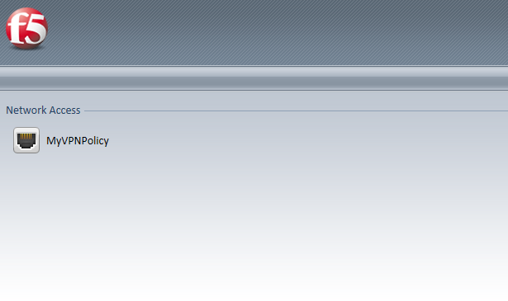

# Lab 5: FORMS Based Authentication

## Objectives

In this lab, we will show you how to configure APM to leverage SSO functionality with an application server that uses forms based authentication.

## Lab Requirements

* BIG-IP with APM licensed and activated
* Server running AD and Web services
* Local Host file entries on the Jump Host

## Task 1: Create a Pool

1. Browse to **Local Traffic > Pools** and click the ‘**+**’ next to **Pools List** to create a new pool.
2. Name the pool “**forms_pool**”
3. Assign the monitor “**http**” by selecting the monitor and moving it to the left.
4. **Add** the following new member/node to the pool and click **Finished**:
   1. Address: **10.128.20.204**
   2. Service Port: **80**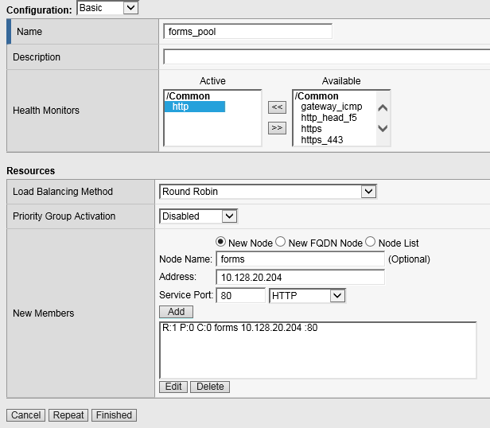

## Task 2: Create a Virtual Server

1. Browse to **Local Traffic > Virtual Servers** and click the ‘**+**’ next to **Virtual Server List** to create a new one.
2. Use the following information to create the virtual server and leave the other settings at their default values:

* Name the pool “**forms_vs**”
* Destination Address/Mask: **10.128.10.12**
* Service Port: **443**
* HTTP Profile: **http**
* SSL Profile (Client): **f5demo**
* Source Address Translation: **Auto Map**
* Default Pool: **forms_pool**  
  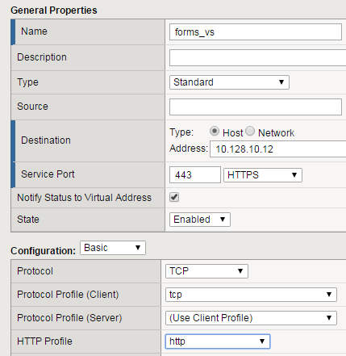  
    
  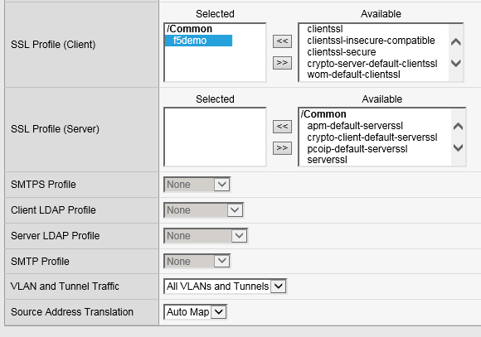  
    
  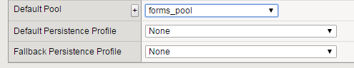

1. Click **Finished**

## Task 3: Testing without APM

Observe the current behavior of the login page without authentication enforced by APM.

1. Open your web browser and go to [**https://forms.f5demo.com**](https://forms.f5demo.com)You should see a page that looks as follows:  
   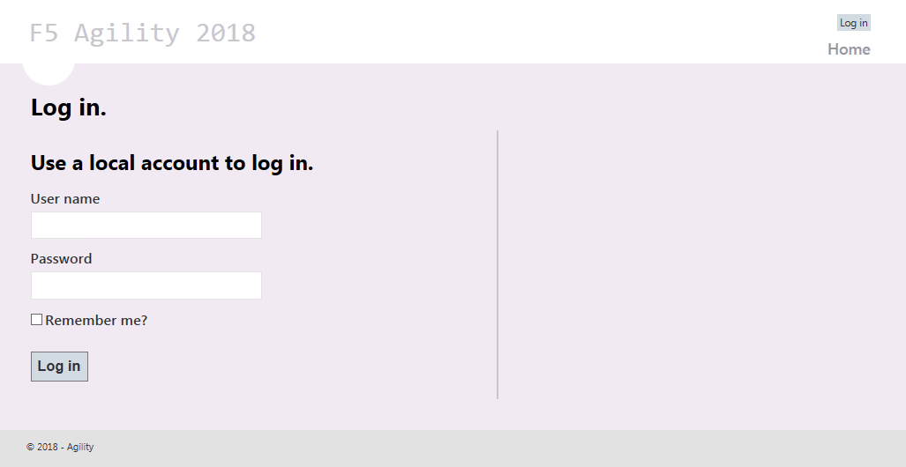
2. Log in with the following credentials:

Username: **user**

Password: **Agility1**

Once successfully logged in you should see a web page similar to the following: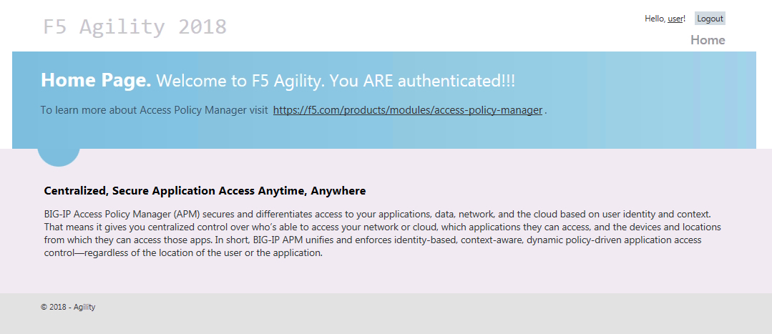

1. **Logout** using the link at the top right-hand corner of the page.

## Task 4: Create Access Policy to use with Forms Based Authentication

1. Open the **Wizards > Device Wizards** page.
2. Select **Web Application Access Management for Local Traffic Virtual Servers**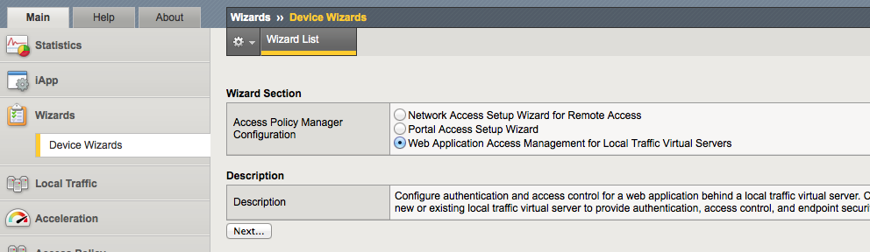
3. Click **Next**
4. Click **Next** for Option 1 on the Configuration Options page  
   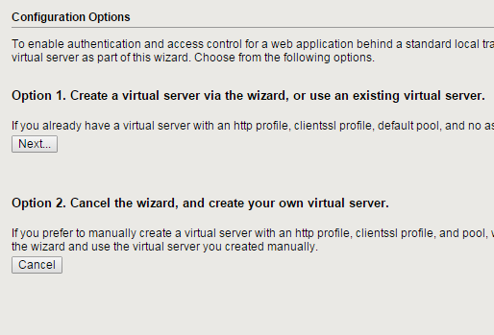
5. Configure Basic Properties for the policy
   1. For Policy Name enter **Forms_Access_Policy**
   2. Uncheck **Enable Antivirus Check in Access Policy**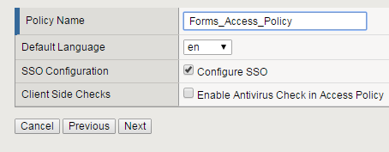
   3. Click **Next**
6. Configure the Authentication type used for this new policy
   1. Select **Use Existing** for the Authentication Options
   2. Select **Lab_SSO_AD_Server::Active Directory**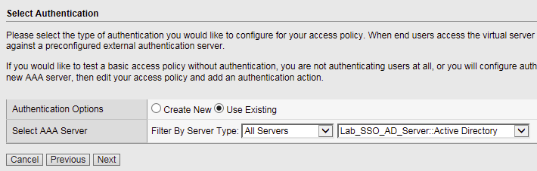
   3. Click **Next**
7. Configure Single Sign On
   1. Select “**Create New**” for “SSO Options”
   2. Choose **Form Based** for the SSO Method
   3. **Uncheck** the option for “Use SSO Template”
   4. Enter **/Account/Login\*** in the “Start URI” field
   5. Enter **/Account/Login** in the “Form Action” field
   6. Enter **UserName** in the “Form Parameter For User Name” field
   7. Enter **Password** in the “Form Parameter For Password” field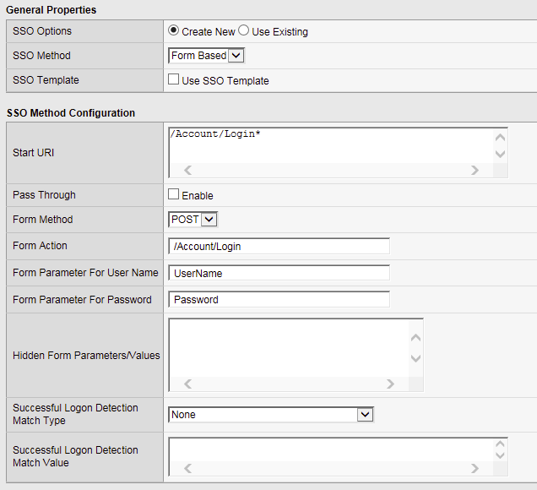
   8. Click **Next**
8. Configure Virtual Server
   1. Select Use **Existing HTTPS Server**
   2. Choose **/Common/forms_vs** for the Virtual Server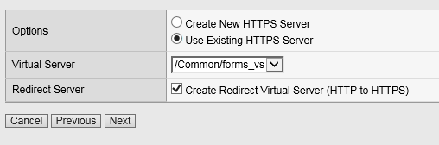
   3. Click **Next**
9. Review configuration and click **Next**
10. Review the “Setup Summary”, which shows all (existing and new) objects associated with this new policy and click **Finished**
11. Add a logout URI Include to the new access policy
    1. Open the **Access > Profiles / Policies > Access Profiles (Per-Session Policies)** page
    2. Click on the name of the new policy **Forms_Access_Policy**
    3. **Add** “**/Account/Logout**” to the “Logout URI Include” field
    4. Change **Logout URI Timeout** to **1** second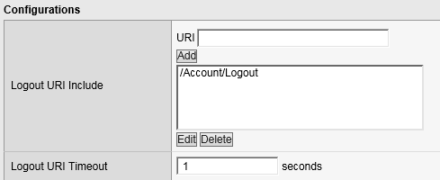
    5. Click **Update**
12. Enable SSO
    1. Click on the “SSO / Auth Domains” tab
    2. For “SSO Configuration”, select **Forms_Access_Policy_sso   
       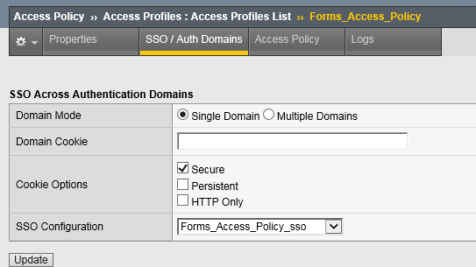**
    3. Click **Update**

## Task 5: Applying Access Policy Changes

After you create or change an access policy, the link Apply Access Policy appears in yellow at the top left of the BIG-IP Configuration utility screen. You must click this link to activate the access policy for use in your configuration.  
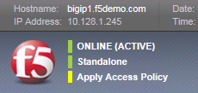

1. Click the **Apply Access Policy** link, which will bring you to the Apply Access Policy screen, with a list of access policies that have been changed.
2. Select the new Access Policy and click the **Apply** button (by default, all access policies that are new or changed are selected).  
   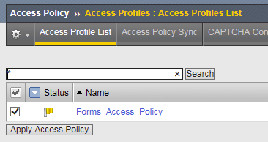  
   After you apply the access policy, the Access Profiles list screen is displayed.

## Task 6: Testing with APM Authentication

Observe the behavior of the login page now that authentication is enforced by APM.

1. Open your web browser and go back to **https://forms.f5demo.com**You should see a page that looks like the following:  
   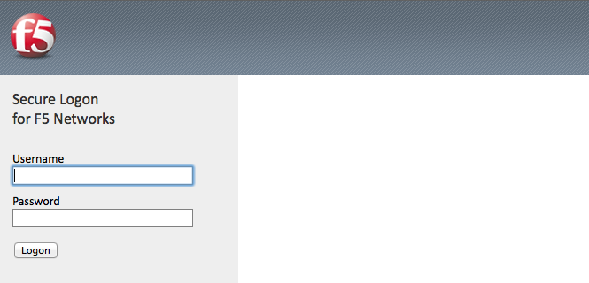
2. Logon with the following credentials:

Username: **user**

Password: **Agility1**

Once successfully logged in you will see the same web page observed in task 2:  
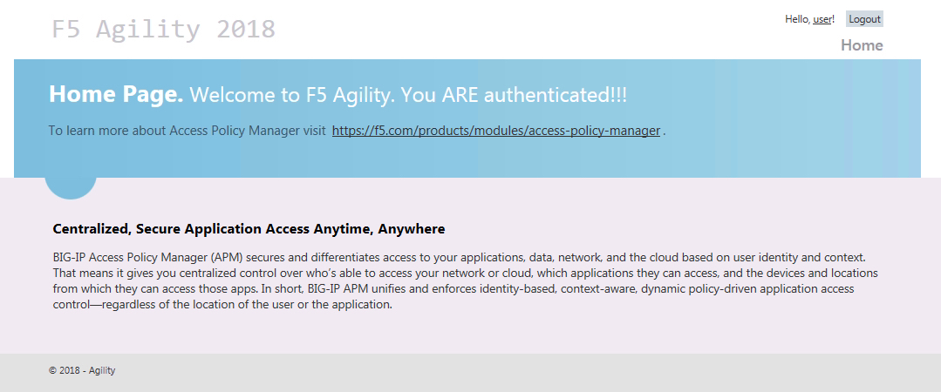

## Task 7: Testing Logout

Earlier in Task 3, Step 9, we defined a **Logout URI Include** for this Access Policy. This is a list of logoff URIs that the access profile searches for in order to terminate the Access Policy Manager session. The URI we used was /Account/Logout, and the default logout delay is 5 seconds which was modified to 1 second.

1. Logout using the **Logout** link at the top right-hand corner of the page.
2. Wait 1 second
3. Click the Home link in the banner at the top of the page
4. You should be redirected back to the F5 logon page

# Lab 6: BASIC Authentication

## Objectives

In this lab, we will show you how to configure basic authentication leveraging the SSO functionality of APM.

## Lab Requirements

* BIG-IP with APM licensed and activated
* Server running AD and Web services
* Local Host file entries on the Jump Host

## Task 1: Create a Pool

1. Browse to **Local Traffic > Pools** and click the ‘**+**’ next to **Pools List** to create a new pool.
2. Name the pool “**basic_pool**”
3. Assign the monitor “**http**” by selecting the monitor and moving it to the left.
4. **Add** the following “New Member/Node” to the pool and click **Finished**:
5. Address: **10.128.20.203**
6. Service Port: **80**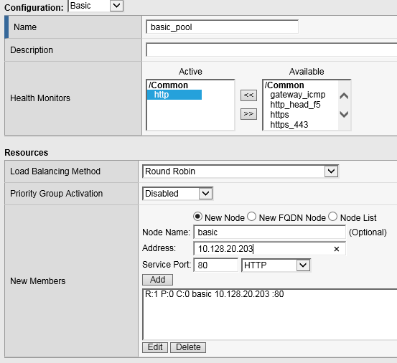

## Task 2: Create a Virtual Server

1. Browse to **Local Traffic > Virtual Servers** and click the ‘**+**’ next to **Virtual Server List** to create a new one.
2. Use the following information to create the virtual server and leave other settings as default:

* Name the pool “**basic_vs**”
* Destination Address: **10.128.10.13**
* Service Port: **443**
* HTTP Profile: **http**
* SSL Profile (Client): **f5demo**
* Source Address Translation: **Auto Map**
* Default Pool: **basic_pool**  
    
  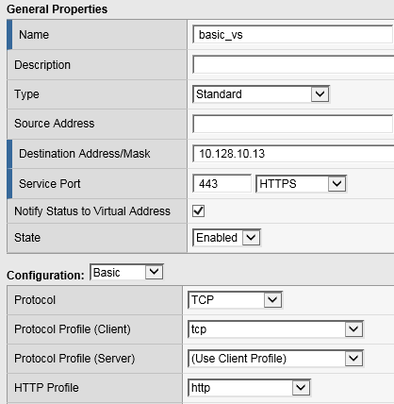  
    
    
    
  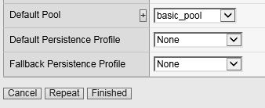

1. Click **Finished**

## Task 3: Testing without APM

Observe the current behavior of the login page without APM authentication.

1. Open a private browsing window and go to **https://basic.f5demo.com**You should receive a prompt that looks similar to the following screen shot:  
   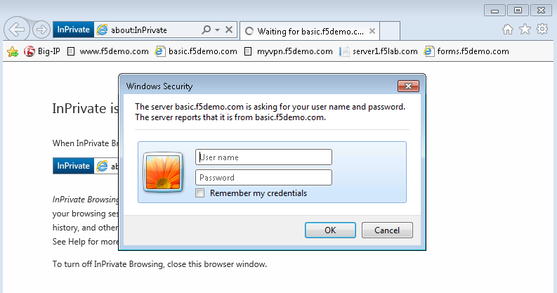
2. Enter the following credentials:

* Username: **user**
* Password: **Agility1**

1. Once successfully logged in you will see a webpage similar to this one:  
   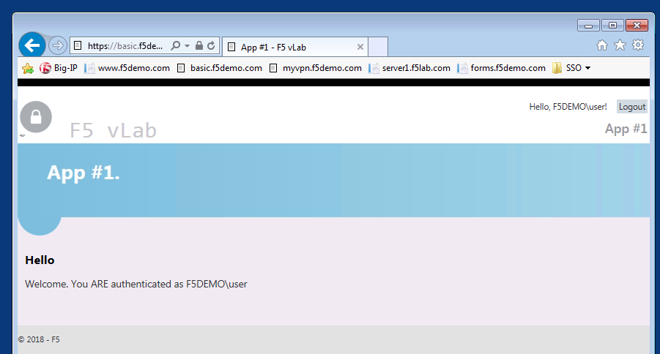
2. Close the private browsing window.

## Task 4: Create Access Policy to use with Basic Authentication

1. Open the **Wizards > Device Wizards** page.
   1. Select **Web Application Access Management for Local Traffic Virtual Servers**
   2. Click **Next**
2. Click **Next** for Option 1 on the Configuration Options page  
   
3. Configure Basic Properties for the policy
   1. For Policy Name enter **Basic_Access_Policy**
   2. **Uncheck** “Enable Antivirus Check in Access Policy”  
      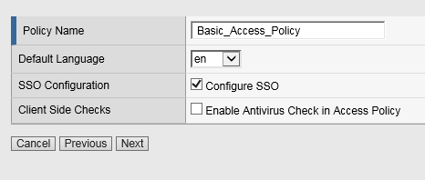
   3. Click **Next**
4. Configure Authentication type used for policy
   1. Select **Use Existing** for the “Authentication Options”
   2. Select **Lab_SSO_AD_Server::Active Directory**
   3. Click **Next**
5. Configure SSO
   1. Select **Create New** for the “SSO Options”
   2. Choose **HTTP Basic**
   3. Click **Next**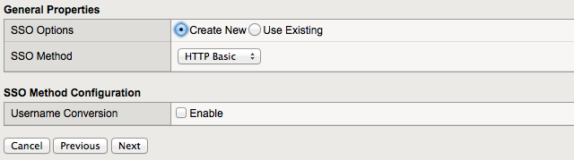
6. Configure Virtual Server
   1. Select Use **Existing HTTPS Server**
   2. Choose **/Common/basic_vs** for the Virtual Server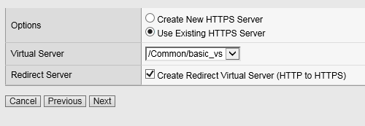
   3. Click **Next**
7. Review configuration and click **Next**
8. Review the “Setup Summary”, which shows all (existing and new) objects associated with this new policy.
9. Click **Finished**
10. Add a logout URI Include to the new access policy
    1. Open the **Access > Profiles / Policies > Access Profiles (Per-Session Policies)** page
    2. Click on the name of the new policy **Basic_Access_Policy**
    3. **Add** “**/Home/Logout**” to “Logout URI Include”
    4. Change **Logout URI Timeout** to **1** second   
       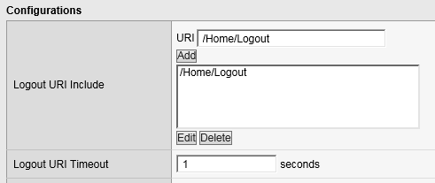
    5. Click **Update**
11. Enable the SSO Configuration
    1. Click on the **SSO / Auth Domains** tab
    2. For **SSO Configuration**, select **Basic_Access_Policy_sso**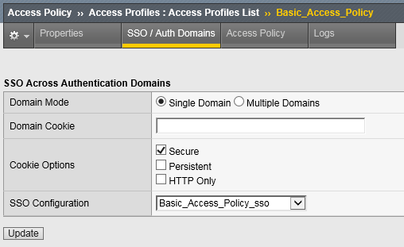
    3. Click **Update**

## Task 5: Applying Access Policy

After you create or change an access policy, the link Apply Access Policy appears in yellow at the top left of the BIG-IP Configuration utility screen. You must click this link to activate the access policy for use in your configuration.  


1. Click the **Apply Access Policy** link, which will bring you to the Apply Access Policy screen, with a list of access policies that have been changed.
2. Select the Access Policy and click the **Apply** button (by default, all access policies that are new or changed are selected).  
   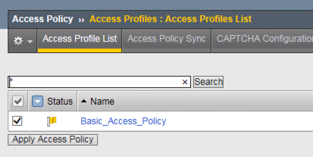  
   After you apply the access policy, the Access Profiles list screen is displayed.

## Task 6: Testing with APM Authentication

Observe the behavior of the login page with authentication enforced by APM.

1. Open a private browsing window and go to **https://basic.f5demo.com**You should see a page that looks like the following:  
   
2. Logon with the following credentials:

Username: **user**

Password: **Agility1**

Once successfully logged in you will see the same web page observed in task 3:  


## Task 7: Testing Logout

Earlier in Task 3, Step 9, we defined a **Logout URI Include** for this Access Policy. This is a list of logoff URIs that the access profile searches for in order to terminate the Access Policy Manager session. The URI we used was /Home/Logout, and the default logout delay is 5 seconds which was modified to 1 second.

1. Click the **Logout** link located at the top right of the web pagee
2. Wait 1 second
3. Click the “**App #1**” link in the banner at the top of the page
4. You should be redirected back to the F5 logon page

# Lab 7: Single-Sign-On Across Authentication Domains

## Objectives

In this lab, we will show you how to provide SSO across multiple applications. Normally APM will require authentication each time an application is accessed. By using a Domain Cookie it is possible to re-use an existing APM session to access multiple applications.

## Lab Requirements

* Previous Labs 5 and 6 successfully completed

## Task 1: Verify Authentication Required for different applications

1. Open a Private web browser or clear your browser cache and go to the Virtual Server used earlier **https://basic.f5demo.com**
2. You should be able to logon with the following credentials:

* Username: **user**
* Password: **Agility1**

1. Once successfully logged in, you will be presented with the same information page you observed earlier from basic.f5demo.com “App #1”.
2. Now go to **https://app2.f5demo.com** you should be prompted to logon again.
3. You should be able to logon with the following credentials:

* Username: **user**
* Password: **Agility1**

1. Once successfully logged in, you will be presented with information about “App #2”.
2. Logout and close the browser window.

## Task 2: Specify Domain Cookie

1. Open the **Access > Profiles / Policies > Access Profiles (Per-Session Policies)** page
2. Click on the name of the policy **Basic_Access_Policy**
3. Click on the **SSO / Auth Domains** tab
4. Enter **f5demo.com** to **Domain Cookie**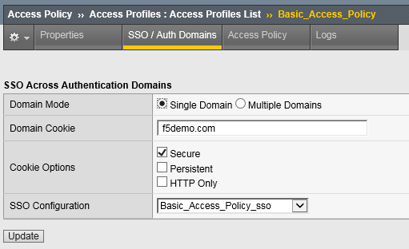
5. Click **Update**
6. Don’t forget to click on **Apply Access Policy** to put your changes in effect!

## Task 3: Testing Authentication across domains

1. Open a Private web browser or clear your browser cache and go to the Virtual Server used earlier **https://basic.f5demo.com**
2. You should be able to logon with Username: **user** and Password: **Agility1**
3. Once successfully logged in, you will be presented with the same information page you observed earlier.
4. Now go to **https://app2.f5demo.com**.  
   You should not be prompted to logon again!

## Task 4 (Bonus): Authentication across domains & virtual servers

Repeat the previous steps, but for Forms_Access_Policy instead of Basic_Access_Policy.

Are you prompted for authentication when going from **https://forms.f5demo.com** to **https://basic.f5demo.com**?

Try changing the value for “Profile Scope” for **Basic_Access_Policy** and **Forms_Access_Policy** from Profile to **Global**

*Troubleshooting tips:

Did you forget to **Apply Access Policy** ?

Verify the Domain Cookie configured on the SSO page… for both policies?

|  |
| --- |
| F5 Networks, Inc. | f5.com |
| US Headquarters: 401 Elliott Ave W, Seattle, WA 98119 | 888-882-4447 // Americas: info@f5.com // Asia-Pacific: apacinfo@f5.com // Europe/Middle East/Africa: emeainfo@f5.com // Japan: f5j-info@f5.com  ©2017 F5 Networks, Inc. All rights reserved. F5, F5 Networks, and the F5 logo are trademarks of F5 Networks, Inc. in the U.S. and in certain other countries. Other F5 trademarks are identified at f5.com. Any other products, services, or company names referenced herein may be trademarks of their respective owners with no endorsement or affiliation, express or implied, claimed by F5. These training materials and documentation are F5 Confidential Information and are subject to the F5 Networks Reseller Agreement. You may not share these training materials and documentation with any third party without the express written permission of F5. |